# Chapter 1

## The Real-Time Environment

Overview 2

* 1. When is a Computer System Real-Time? 3
  2. Functional Requirements 6
  3. Temporal Requirements 13
  4. Dependability Requirements 17
  5. Classification of Real-Time Systems 21
  6. Automotive Real-Time Systems 23

1.7 Points to Remember 25

## Overview

* Describing the environment of real-time computer systems from various perspectives
* Definition of a real-time system with discussion of functional and metafunctional requirements
* Emphasis on temporal requirements derived from control applications; satisfying performance criteria in control applications; quality of control
* Difference between hard and soft real-time systems
* Soft real-time systems may follow a less rigorous design approach, accepting failure under peak load conditions due to economic arguments
* In hard real-time systems failure is unacceptable; safety of a design under all circumstances must often be demonstrated to a certification agency
* Automobiles as assembly of many dedicated real-time systems

**1.1** **When is a Computer System Real-Time?**

*A real-time computer system is a computer system in which the correctness of the system behavior depends not only on the logical results of the computations, but also on the physical instant at which these results are produced.*

A real-time computer system is always part of a larger system, the real-time system.

We decompose a real-time system into a set of subsystems called clusters.

|  |  |
| --- | --- |
|  | Man-Machine-Interface: keyboard, mouse, screen  Instrumentation-Interface: sensors and actuators, transforming physical signals into a digital form and vice versa |

The controlled object and the operator form the environment of the real-time computer system. Not every node has both, a man-machine interface and an instrumentation interface.

A distributed real-time computer system consists of a set of computer nodes interconnected by a real-time communication network.

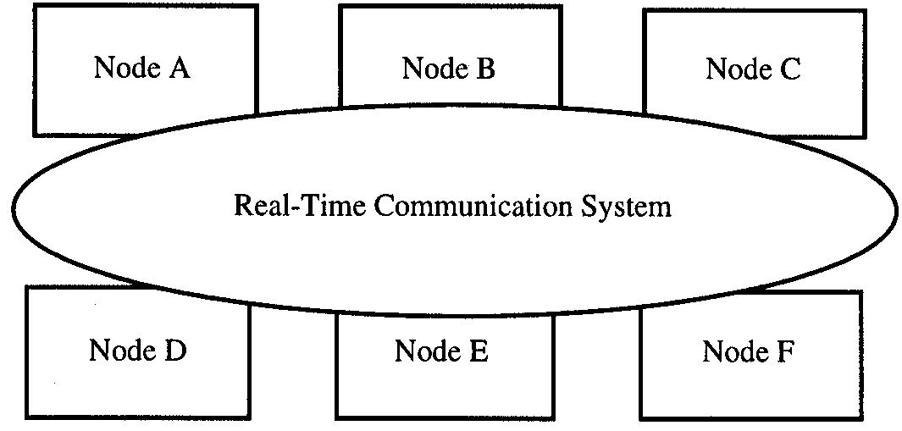

A real-time computer system must react to stimuli from the controlled object or operator within time intervals dictated by the environment.

The instant at which the result must have been produced is called a deadline.

Soft deadline: result has some utility passed this instant in time.

Firm deadline: result has no or very little utility past this instant in time.

Hard deadline: catastrophic failure when result is produced past this instant in time.

Hard real-time computer system or safety-critical real-time computer system:

* A real-time system that must meet at least one hard deadline.

Soft real-time computer system:

* A real-time computer system for which no hard deadline exists.

**1.2** **Functional Requirements**

Functional Requirements are grouped into

* Data collection requirements
* Direct digital control requirements
* Man-machine interaction requirements

## Data Collection

A controlled object (car, industrial plant) changes its state as a function of time.

Current state: values of all state variables at this moment

Example: speed of car, position of switches on dashboard, position of piston in a cylinder

We are normally only interested in a subset of state variables significant for our purpose:

* A significant state variable is called a real-time (RT) entity.

Every RT entity is in the sphere of control (SOC) of a subsystem, i.e., it belongs to a subsystem that can change the value of that RT entity.

Outside that SOC the value of that entity can only be observed, not modified.

Thus, we have the following functional requirements:

* Observation of the RT entities in a controlled object
* Collection of these observations

An observation of an RT entity is represented by a real-time (RT) image.

Example for accuracy interval:

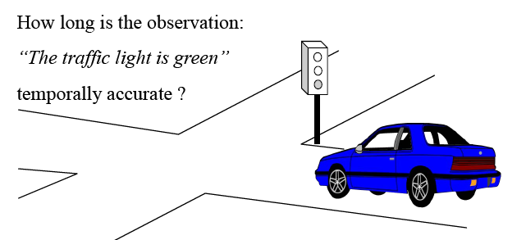

If the information „traffic light is green“ is used outside its accuracy interval, a collision may occur.

The set of all temporally accurate RT images of the controlled object is called the real-time database.

The RT database must be updated whenever an RT entity changes its value.

The update can be performed periodically with a fixed period (time-triggered (TT) observation).

The update can be performed immediately after a state change in the RT entity, which constitutes an event (event-triggered (ET) observation).

**Signal conditioning**

Signal conditioning encompasses all processing steps to obtain meaningful measured data from physical sensor data (raw data element, e.g. a voltage). Typical processing steps:

* filtering and averaging
* plausibility checks
* calibration and transformation

Agreed data element: a data element judged to be a correct RT image of the corresponding RT entity.

**Alarm monitoring**

Alarm monitoring serves to detect abnormal behaviour by continuous observation of RT entities.

Example: rupture of a pipe in a chemical plant will cause many RT entities (pressures, temperatures, liquid levels) deviate from their normal operating ranges.

The rupture will lead to a set of correlated alarms, which is called an alarm shower.

The computer system must detect and display these alarms, and must try to identify the primary event (the initial cause of the alarm).

Alarms are logged with the exact time at which they occur. The time stamp helps to eliminate secondary alarms.

A situation that occurs infrequently but is of great concern when it does is called a rare-event situation. Rare-event performance validation is a great challenge (e.g. nuclear plants).

## Direct Digital Control

Many real-time computer systems must calculate set points for the actuators and control the controlled object directly. Example: engine controller

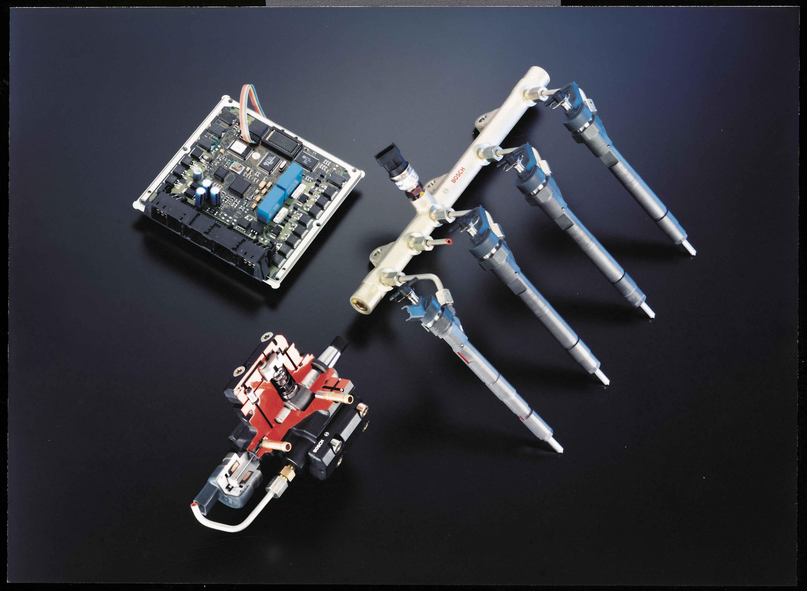

Control applications are highly regular, consisting of an infinite sequence of control periods:

* Sampling of the RT entity
* Execution of the control algorithm to calculate a new set point
* Output of set point to actuator

Design of control algorithms is topic of field of control engineering.

## Man-Machine Interaction

A real-time computer system must inform the operator of the current state of the controlled object, and must assist the operator in controlling the machine or plant object.

The man-machine interface in safety-critical real-time systems is of utmost importance. A bad design can result in catastrophic failures.

|  |  |
| --- | --- |
|  | Automotive examples:   * Dashboard * Joystick * Steering wheel * Brake, accelerator pedal   This topic justifies a lecture on its own, and is not dealt with any further here. |

**1.3** **Temporal Requirements**

* Most stringent temporal demands come from control loops, e.g. control of fast mechanical processes such as automotive engines
* Requirements at the MMI are less stringent (human perception delay is between 50-100 ms)
* Example for a simple control loop: control steam flow through pipe such that liquid temperature remains at set point.

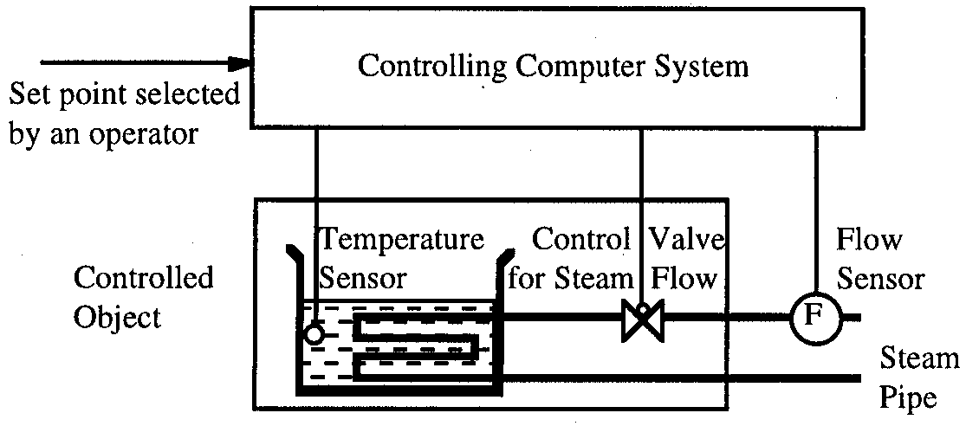

Behavior of liquid temperate when steam flow is increased instantly by a fixed amount: response function of the temperature.

Response function characterized by two temporal parameters: object delay *dobject* or process lag and rise time *drise* of the temperature

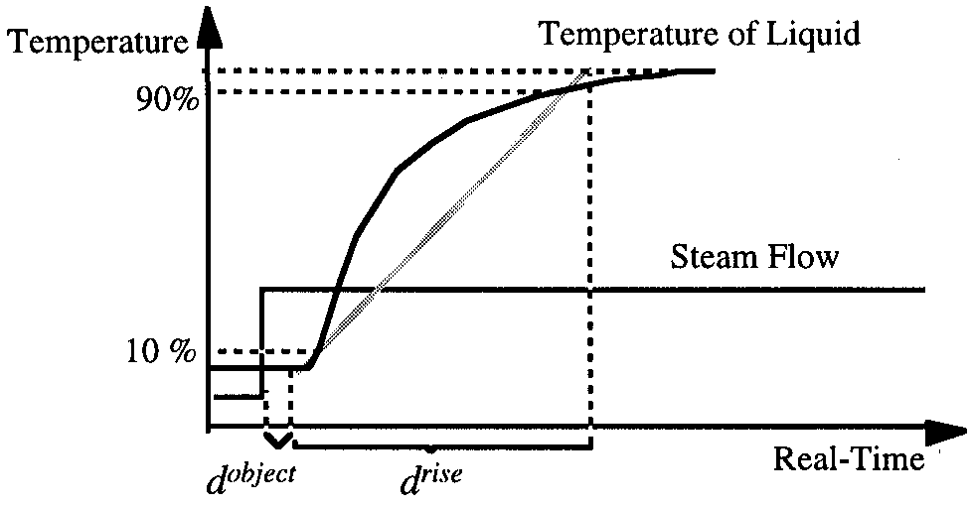

Controlling computer system samples temperature of vessel periodically with sampling period *dsample*. The sampling frequency is *fsample* = *1/ dsample* .

Rule of thumb: sampling period should be less than one-tenth of the rise time *drise* of controlled object to obtain quasi-continuous behavior (*dsample < drise*/*10*).

The computer system calculates the new value for the control variable, and outputs it to the control valve after some delay, called the computer delay *dcomputer*. The computer delay should be less than the sampling period *dsample*.

The jitter *dcomputer* is the difference between the maximum and minimum computer delay. It should be small compared to the computer delay *dcomputer* (s to ms). The jitter can be interpreted as causing an additional error of the temperature *T.*

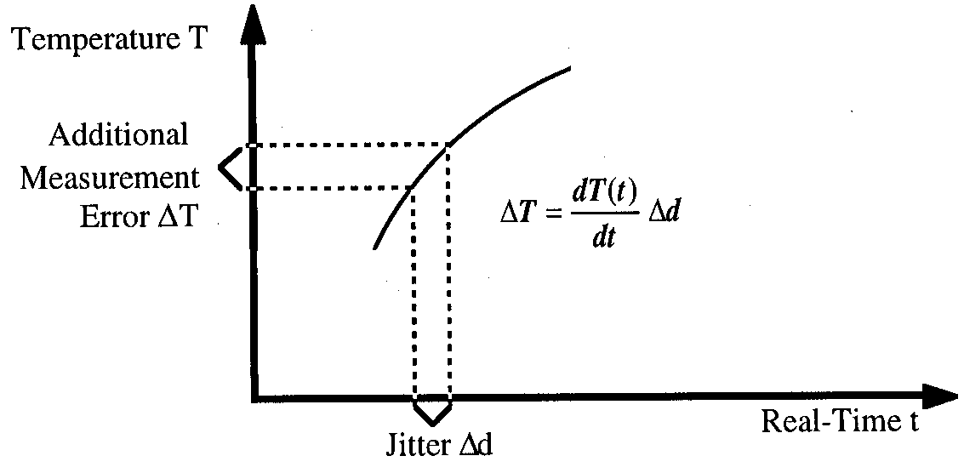

The dead time *ddeadtme* is the time interval between the observation of the RT entity and the start of a reaction of the controlled object due to a computer action.

The dead time is *dobject* + *dcomputer*.

Dead time reduces stability of the control loop, and should thus be as small as possible.

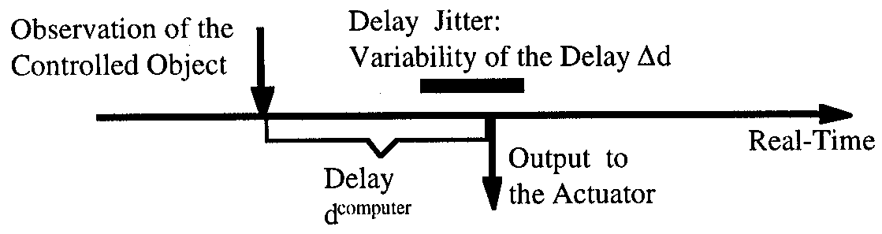

Hard real-time applications are, by definition, safety-critical. Errors must therefore be detected within a short time with high probability. The required error detection latency must be in the order of magnitude of the sampling period of the fastest control loop.

**1.4** **Dependability Requirements**

Dependability is determined by:

* Reliability
* Safety
* Maintainability
* Availability
* Security

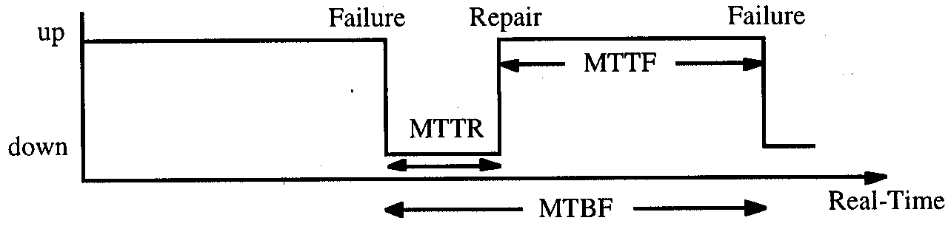

**Reliability**

Reliability R(t) is the probability that a system will provide the specified service until time *t*, given that the system was operational at time *t0*.

If a system has a constant failure rate ** *failures/hour*, then *R(t)* is given by

*R(t) = exp(- (t-t0))* (with t and t0 given in hours)

The inverse of the failure rate *1/  MTTF * is called the Mean-Time-To-Failure (in hours).

**Safety**

Safety is reliability regarding critical failure modes (malign failure modes). Examples of malign failures:

* airplane crash due to a failure in the flight-control system
* automobile accident due to a failure in the computer controlled braking system

Hard real-time systems must have a failure rate conforming to ultrahigh reliability requirements (*Lambda 10-9 failures/hour* or less). Example: one such failure per one million cars per year, when car is operated one hour per day.

**Maintainability**

Maintainability is a measure of the time required to repair a system after the occurrence of a benign failure (non safety-critical failure). It is measured by the probability M(d) that the system is restored within a time interval *d* after the failure.

Similar to reliability, there is a repair rate ** ; the inverse of the repair rate *1/  MTTR * is called the Mean-Time-To-Repair (in hours).

Reliability and maintainability are in conflict to each other (e.g. soldered connection vs. plug). Many replaceable units improve maintainability and reduce reliability. In automotive market typically OEMs decide for reliability at the cost of maintainability.

**Availability**

Availability is a measure of the delivery of correct service with respect to the alternation of correct and incorrect service. It is measured by the fraction of time the system is ready to provide the service.

In systems with constant failure and repair rates, the reliability (*MTTF*), maintainability (*MMTR*) and availability (*A*) measures are related by

*A = MTTF / (MTTF+MTTR)*

The sum of *MTTF* and *MTTR* is called the Mean Time Between Failures (*MTBF*).



A high availability can be achieved by high *MTTF* or by a short *MTTR*.

**Security**

Security is the ability of a system to prevent unauthorized access to information or services. Examples in the automotive context are:

* Ignition lock for theft avoidance
* Car access with lock system
* Protection against software reverse engineering and manipulation

There is no standardized quantitative measure for security.

**1.5** **Classification of Real-Time Systems**

**Fail-Safe versus Fail-Operational**

Fail safe: controlled object can enter a safe state where nothing bad can happen (e.g. all traffic lights switched to red, all trains stopped). Fail-safeness is property of controlled object, not of computer system.

Fail-operational: system must be still operational in case of failure (airplane, no safe state).

**Guaranteed-Response versus Best-Effort**

We assume some peak load and a fault model. If we can buy design guarantee adequate responses under all conditions, without reverting to probability arguments, we can speak of a system with a guaranteed response. Guaranteed response systems usually require careful planning and extensive analysis during the design phase.

In case we cannot guarantee adequate response by design, we speak of a best effort system.

It is very difficult to demonstrate that a best-effort design operates correctly under rare event scenarios. There is always a fall back default value in case the requested value cannot be responded in real time.

**Resource-Adequate versus Resource-Inadequate**

Guaranteed response systems must have enough resources to handle a specified peak load and fault scenario. Due to economic reasons many non safety-critical real-time systems are based on the principle of resource inadequacy.

**Event-Triggered versus Time-Triggered**

In the event-triggered approach, all communication and processing activities are initiated whenever a significant change of state is noted. Notification to the computer system via interrupts. Requires dynamic scheduling strategy. The event bus defines the priority of concurrent events.

In the time triggered approach, all communication and processing activities are initiated at predetermined points in time. Only one interrupt, the periodic clock interrupt. In a distributed system there needs to be some notion of a synchronized global time. A task has to start every 100ms.

The flow of control in a time triggered system is managed by the progression of time, while in an event driven system, the flow of control is determined by the events that happen in the environment or the “computer system”. Examples?

**1.6** **Automotive Real-Time Systems**

**Engine control**

In a modern engine controller, upto 100 concurrently software tasks must cooperate in tight synchronisation to achieve the desired goal.

Consider combustion engine with injection valve. The start point of fuel injection must be precise within 0.1° of the measured angular crankshaft position.

Crankshaft turns with 6000 rpm; that means 10 ms for a 360° rotation. Precision of 0.1° transforms into a temporal accuracy of 3 s.

The fuel injection is realized by opening a piezo-electric valve that controls the fuel flow from a high-pressure reservoir into the cylinder. The latency between giving the valve the “open” command and the actual point in time when the valve opens is in the order of hundreds of s, and changes considerably due to environmental conditions (e.g. temperature).

A sensor signal indicates the point in time when the valve has actually opened to provide the ability to compensate for the latency jitter. The duration between the execution of the output command and the start of opening the valve is measured in each engine cycle, to compensate for the latency jitter in the next cycle.

**Airbag System**

**1.7 Points to Remember**

Here the students can make notes. The lecturer notes would be delivered after the completion of each slide.